MIS275

**Investment POrtfolio optimisation**

SIDDHANT KOHLI

222181609

# **Section 1: Preliminary work**

Investment portfolio optimisation Includes process of selecting , overseeing risk and managing stocks , bonds and other securities from different categories . In our portfolio management optimisation we will leverage mathematical deterministic models which will help us maximise and minimise the profits and risks which have certain feasible constraints with them.

In this portfolio 2 stocks have been selected from 5 different categories including Basic materials , Healthcare , Financial , Technology and Industry goods (Table 1). Portfolio consists of total of 10 different stocks 2 from 5 categories where the stock prices have been taken in consideration on monthly frequency from 1 February 2021 – 29 February 2024 (37 months). The monthly returns and risk involved with the stocks were calculated which gave the room to optimise the portfolio (Table 2). Finally returns on stock was used to determine average returns and average standard deviation to determine average risk.

|  |  |
| --- | --- |
| **Sector** | **Stock Name** |
| **Basic materials** | Rio Tinto Limited (RIO.AX) |
| BHP Group Limited (BHP.AX) |
| **Healthcare** | CSL Limited (CSL.AX) |
| Cochlear Limited (COH.AX) |
| **Financial** | Westpac Banking Corporation (WBC.AX) |
| Commonwealth Bank of Australia(CBA.AX) |
| **Technology** | Computershare limited (CPU.AX) |
| Technology One Limited (TNE.AX) |
| **Industrial goods** | Qantas Airways Limited (QAN.AX) |
| Transurban Group (TCL.AX) |

**Table 1: Portfolio stocks**

Stocks were classified in the risk classification table where 4 risk categories were classified as R1 (Low risk), R2 (Moderate Risk), R3 (Medium Risk) and R4 (High Risk) (Table 3). These were based on the average risk of the stocks which were calculated using standard deviation of monthly returns. R1 reflects low risk , R2 reflects moderate risk , R3 is moderate risk category and lastly R4 is high risk category. The R1 and R4 are poles risk categories with lowest and highest associated and R3 and R4 categories balances out the returns and risks of the stocks. The bins were based on risks associated with the stocks (Standard deviation of monthly returns) (Table 3).

|  |  |  |  |
| --- | --- | --- | --- |
| **Stock** | **Average returns** | **Standard deviation** | **Risk Group** |
| **RIO** | **0.866%** | **0.0855** | **R4** |
| **CSL** | **0.407%** | **0.0523** | **R1** |
| **WBC** | **0.643%** | **0.0713** | **R3** |
| **CPU** | **1.864%** | **0.0675** | **R2** |
| **QAN** | **0.877%** | **0.0758** | **R3** |
| **BHP** | **0.891%** | **0.0839** | **R4** |
| **COH** | **1.382%** | **0.0680** | **R2** |
| **CBA** | **1.164%** | **0.0664** | **R2** |
| **TNE** | **1.982%** | **0.0808** | **R3** |
| **TCL** | **0.250%** | **0.0503** | **R1** |

Table 2

|  |  |
| --- | --- |
| **R1** | 0 – 0.0525 |
| **R2** | 0.0525 - 0.0700 |
| **R3** | 0.0700 - 0.08300 |
| **R4** | > 0.08300 |

Table 3

Final Classified table with risk and categories

# **Section 2: Optimisation model**

**2.1 Linear programming model**

**Algebraic formulation**

The mathematical formulation will build a foundation to optimise the linear programming model and solver function in excel will provide a desired output.

**Decision variables**

Let X1 constitute the weight of investment in stock RIO.AX

Let X2 constitute the weight of investment in stock CSL.AX

Let X3 constitute the weight of investment in stock WBC.AX

Let X4 constitute the weight of investment in stock CPU.AX

Let X5 constitute the weight of investment in stock QAN.AX

Let X6 constitute the weight of investment in stock BHP.AX

Let X7 constitute the weight of investment in stock COH.AX

Let X8 constitute the weight of investment in stock CBA.AX

Let X9 constitute the weight of investment in stock TNE.AX

Let X10 constitute the weight of investment in stock TCL.AX

**Objective:**

**Maximize the overall return:**

**Constraints:**

* Sum of the weights make up an investment should be 100
* **At least 20% of capital should be invested in basic materials (C1)**

I.e. Rio Tinto + BHP Group Limited

* **At least 20% of capital should be invested in Industrial goods (C5)**

I.e. Qantas Airways + Transurban Group

* **At least 15% of capital should be invested in moderate risky stocks (R3)**

I.e. Westpac + Qantas + Technology one

* **At least 25% of capital should be invested in least risky stocks (R1)**

I.e. CSL limited + Transurban group

**Excel structure for optimal solution (LP)**

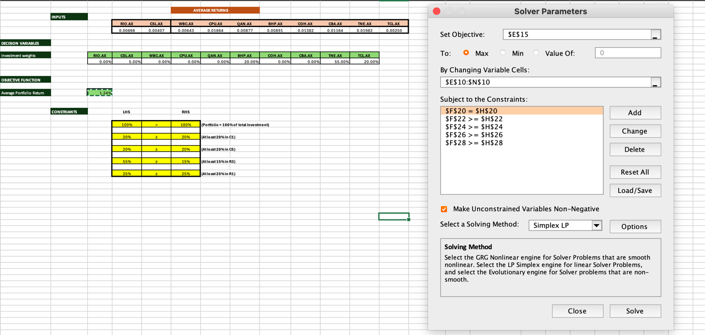

**Solver parameters for LP model**

**Optimal solution:**

To maximise the overall return adhering to constraints , 5% capital should be invested in **CSL** **limited** , 20% should be invested in **BHP group** , 55% of the capital should invested in **Technology one** and 20% should be invested in **Transurban group**. Considering our risks investing in Technology one will not only yield most returns but also moderate risk is associated with it whereas safe investment in CSL and TCL will be least risky with average return of 0.3285% and BHP will be most risky but with concrete returns of 0.891%.

**Sensitivity report:**

In our sensitivity report final value represents proportion of capital which should be invested in the stock (55% should be invested in TNE.AX) . The reduced cost tells us how investing in a certain stock will affect our objective which is to maximise the overall return for example since optimal solution for investing in RIO.AX i.e. our model does not suggests investing in RIO.AX and if 1 unit stock will be invested in RIO.AX our overall returns of portfolio will decrease by -0.0253%. The objective coefficient signifies that how stock contributes more positively in our overall returns, Here TNE.AX contributes most positively in maximising returns. Lastly allowable increase/decrease signifies upper and lower limit of objective coefficient before the optimal solution changes

**2.2 Integer Linear programming model**

The goal is to maximise overall returns with equal weighted portfolio of exact 8 stocks.

**Conceptual diagram:**

**Fixed Inputs :**

**Decision variables:**

**Calculated variables:**

**Output Inputs:**

Investment constraints

8

Sum of investment weights

Average returns

Investment constraints

Maximize overall portfolio return

Weather to invest

**Decision variables:**

Let the decision variables be binary variables:

|  |  |
| --- | --- |
| **Stock** | **Variable** |
| **RIO.AX** | X1 |
| **CSL.AX** | X2 |
| **WBC.AX** | X3 |
| **CPU.AX** | X4 |
| **QAN.AX** | X5 |
| **BHP.AX** | X6 |
| **COH.AX** | X7 |
| **CBA.AX** | X8 |
| **TNE.AX** | X9 |
| **TCL.AX** | X10 |

**Objective:**

**Maximize the overall return:**

**Constraints:**

* **Invest in exactly 8 stocks**
* **All 5 categories must be included**

RIO + BHP 1

CSL + COH 1

CBA + WBC 1

CPU + TNE 1

TCL + QAN 1

* **At least 2 of the assets can be in the least risky group R1.**

CSL.AX + TCL.AX 1

* **No more than 2 of the assets can be in the risk group R3.**

WBC.AX + QAN.AX 1

* **At most 1 must be in riskiest group 1.**

RIO.AX 1

**Optimal solution:**

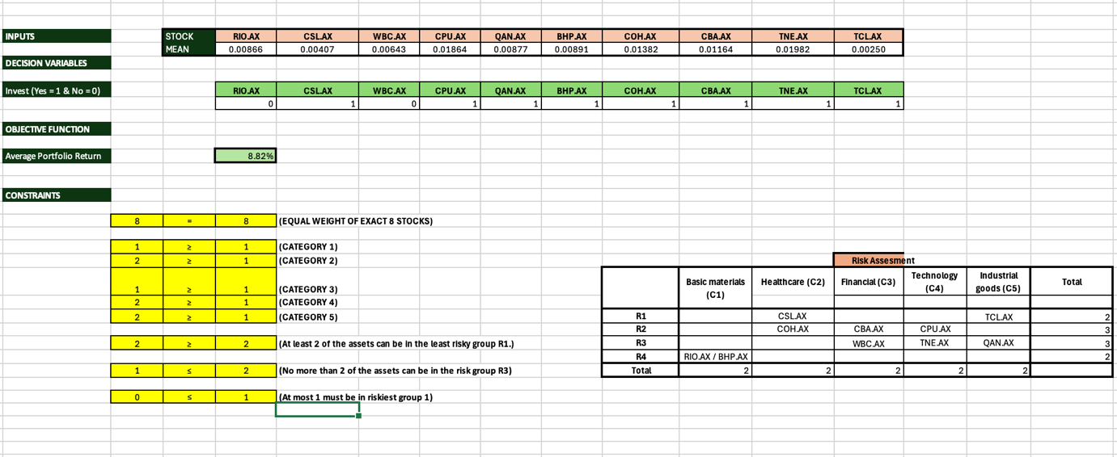

**Structure of integer LP model**

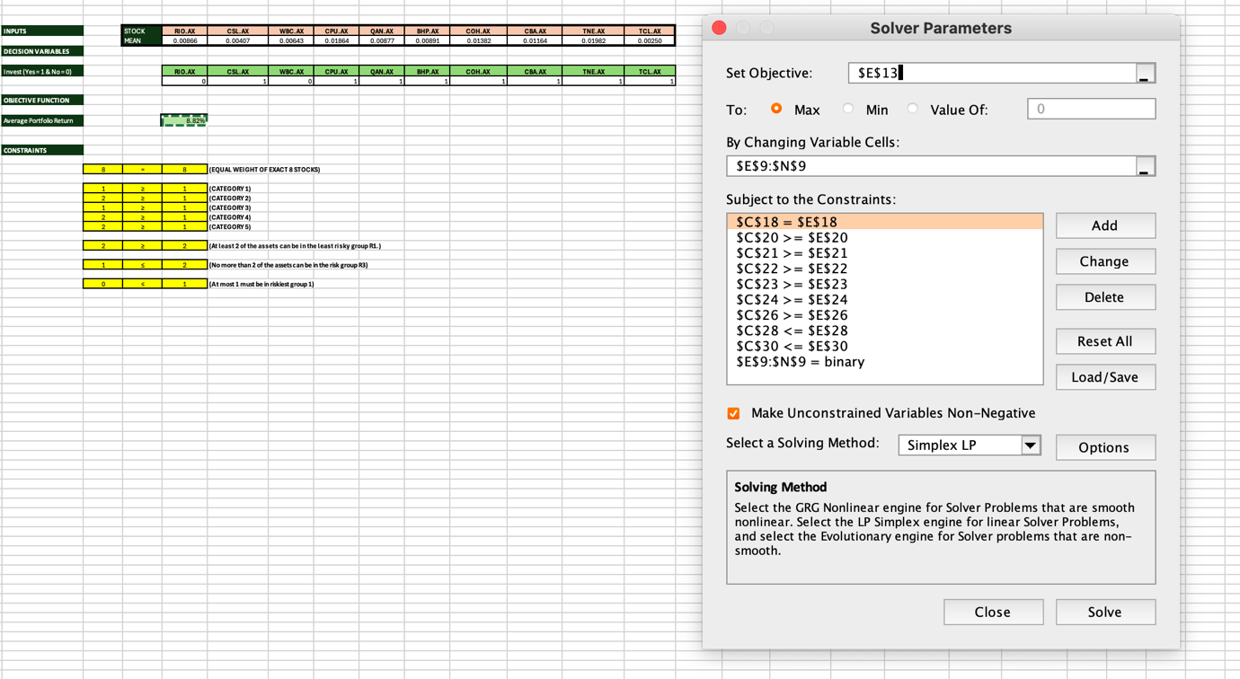

**Solver parameters for ILP model**

**Interpretation**

To maximise the overall returns the capital should be invested in CSL.AX , CPU.AX, QAN.AX, BHP.AX, COH.AX, CBA.AX, TNE.AX, TCL.AX with around 12.5% parts of capital. Investing in these 8 stocks will yield the average portfolio return of 8.82%. This investment will balance out the categories as well as risk associated to stocks.

**2.3 Non-Linear programming model (Maximum risk)**

Maximise overall return subject to an upper limit on portfolio risk

**Algebraic formulation**

The portfolio will be maximised using non-linear programming model with consideration of risk related with the investment.

**Decision Variables**

Let X1 constitute the weight of investment in stock RIO.AX

Let X2 constitute the weight of investment in stock CSL.AX

Let X3 constitute the weight of investment in stock WBC.AX

Let X4 constitute the weight of investment in stock CPU.AX

Let X5 constitute the weight of investment in stock QAN.AX

Let X6 constitute the weight of investment in stock BHP.AX

Let X7 constitute the weight of investment in stock COH.AX

Let X8 constitute the weight of investment in stock CBA.AX

Let X9 constitute the weight of investment in stock TNE.AX

Let X10 constitute the weight of investment in stock TCL.AX

**Objective:**

**Maximize the overall return:**

**Constraints:**

* Sum of the weights make up an investment should be 100

1. **Standard Deviation of the portfolio 4%** (Assuming a maximum limit of risk is 4% on the portfolio)

**Optimal solution:**

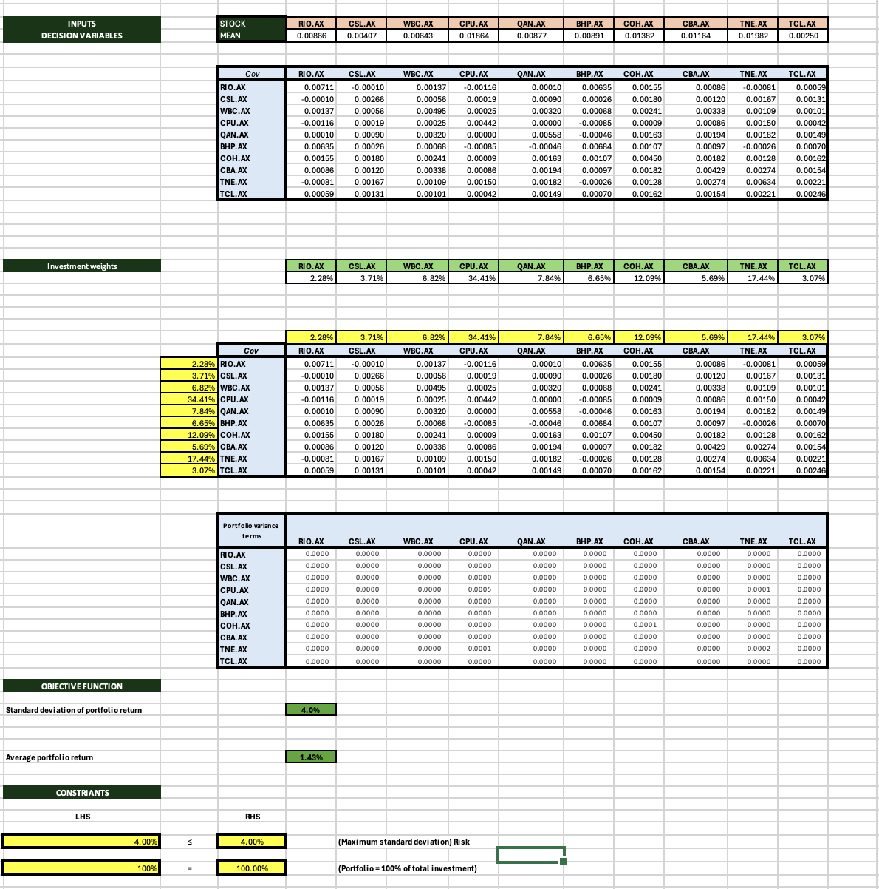

**Structure of non-LP model**

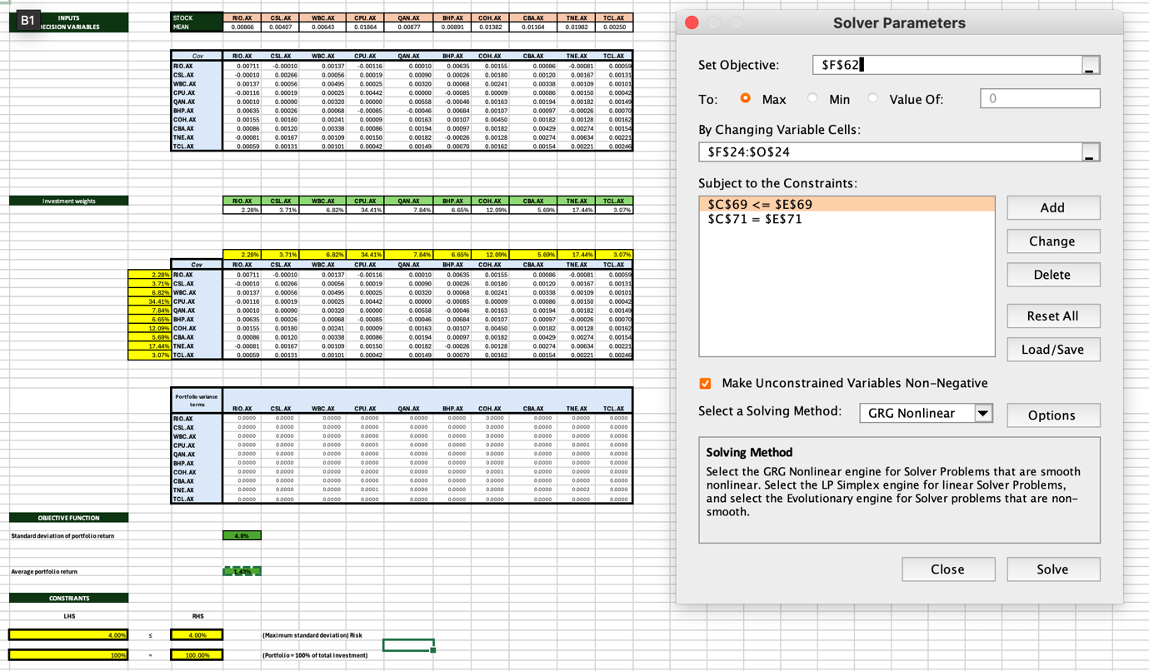

**Solver parameters for NLP model**

**Interpretation:**

Our NLP model provides average portfolio return of 1.43% on investments where the maximum risk tolerant investments can be made at 4%. In comparison with average return and maximum risk associated with investments we can interpret that higher risk should yield more fruitful returns which is not the case here, depending on trade-off one might want to only invest in fraction of stocks like CPU.AX or TNE.AX to maximise the return.

**2.3 Non-Linear programming model (Minimum required return)**

Minimise portfolio risk subject to a requirement to achieve at least a specified return

**Algebraic formulation**

The portfolio will be maximised using non-linear programming model with consideration of risk related with the investment.

**Decision Variables**

Let X1 constitute the weight of investment in stock RIO.AX

Let X2 constitute the weight of investment in stock CSL.AX

Let X3 constitute the weight of investment in stock WBC.AX

Let X4 constitute the weight of investment in stock CPU.AX

Let X5 constitute the weight of investment in stock QAN.AX

Let X6 constitute the weight of investment in stock BHP.AX

Let X7 constitute the weight of investment in stock COH.AX

Let X8 constitute the weight of investment in stock CBA.AX

Let X9 constitute the weight of investment in stock TNE.AX

Let X10 constitute the weight of investment in stock TCL.AX

**Objective function:**

**Constraints:**

* **Sum of the weights make up an investment should be 100**
* **Overall return of the investments should be at least 1.5%**

**Optimal solution:**

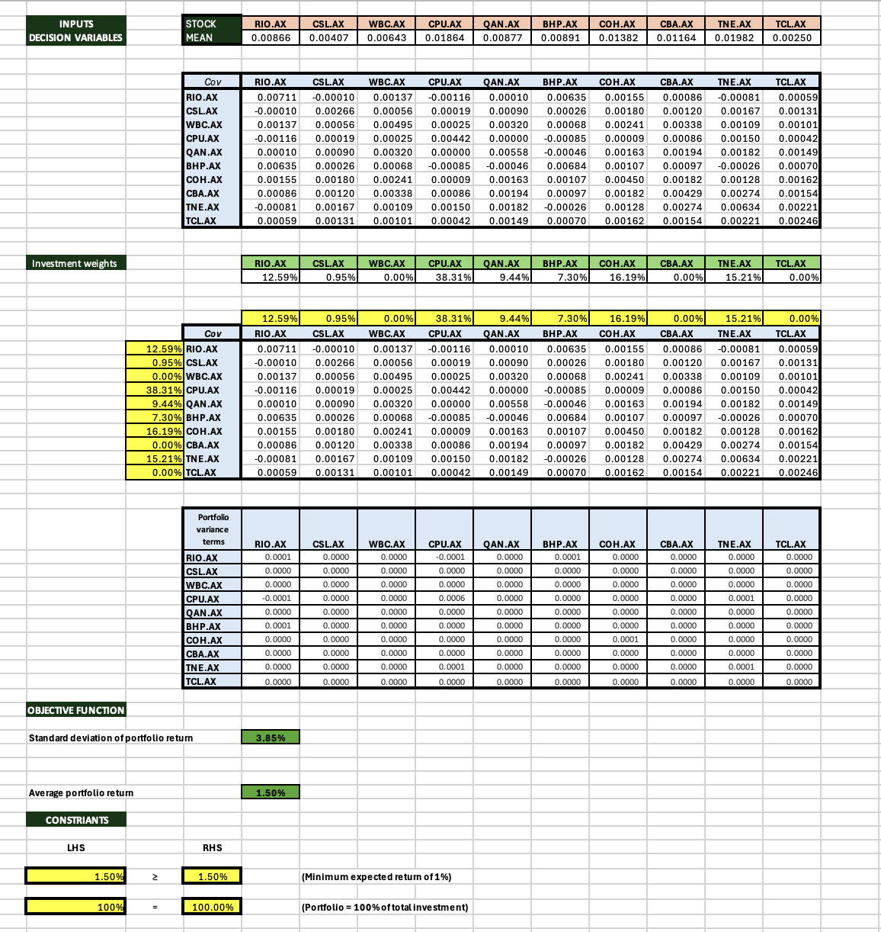

**Structure of non-LP model**

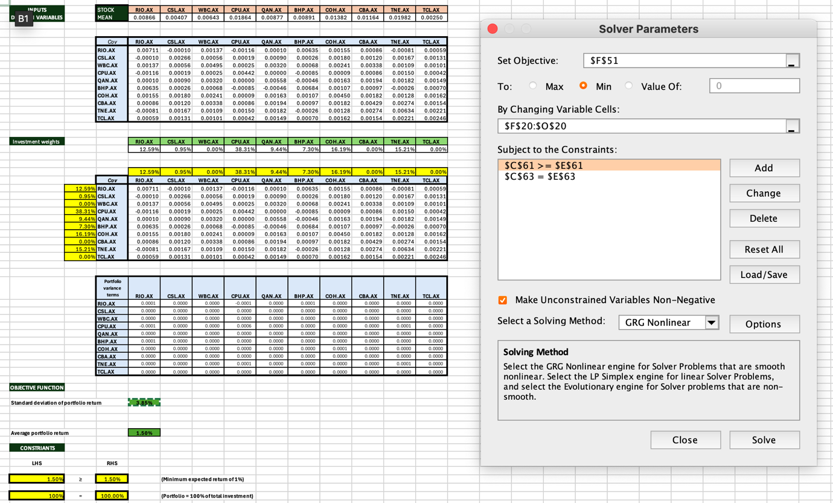

**Solver parameters for NLP model**

**Interpretation:**

Our NLP model suggests that to achieve minimum average return of 1.5% the minimum risk associated with the investments will be 3.85% which is moderate risk in distributed investments. Investing in CPU.AX and COH.AX will be most beneficial and yield most of the average returns given they are mildly risky stocks (R2).

**2.3 Non-Linear programming model (Maximum Sharpe ratio)**

Minimise portfolio risk subject to a requirement to achieve at least a specified return

**Algebraic formulation**

The portfolio will be maximised using non-linear programming model with consideration of risk related with the investment.

**Decision Variables**

Let X1 constitute the weight of investment in stock RIO.AX

Let X2 constitute the weight of investment in stock CSL.AX

Let X3 constitute the weight of investment in stock WBC.AX

Let X4 constitute the weight of investment in stock CPU.AX

Let X5 constitute the weight of investment in stock QAN.AX

Let X6 constitute the weight of investment in stock BHP.AX

Let X7 constitute the weight of investment in stock COH.AX

Let X8 constitute the weight of investment in stock CBA.AX

Let X9 constitute the weight of investment in stock TNE.AX

Let X10 constitute the weight of investment in stock TCL.AX

**Objective function:**

Average portfolio return:

**Sharpe Ratio = (Average portfolio return – 2%)/ Standard deviation of portfolio**

Assumed, 2% as the risk-free rate.

**Constraints:**

* **Sum of the weights make up an investment should be 100**

**Optimal solution:**

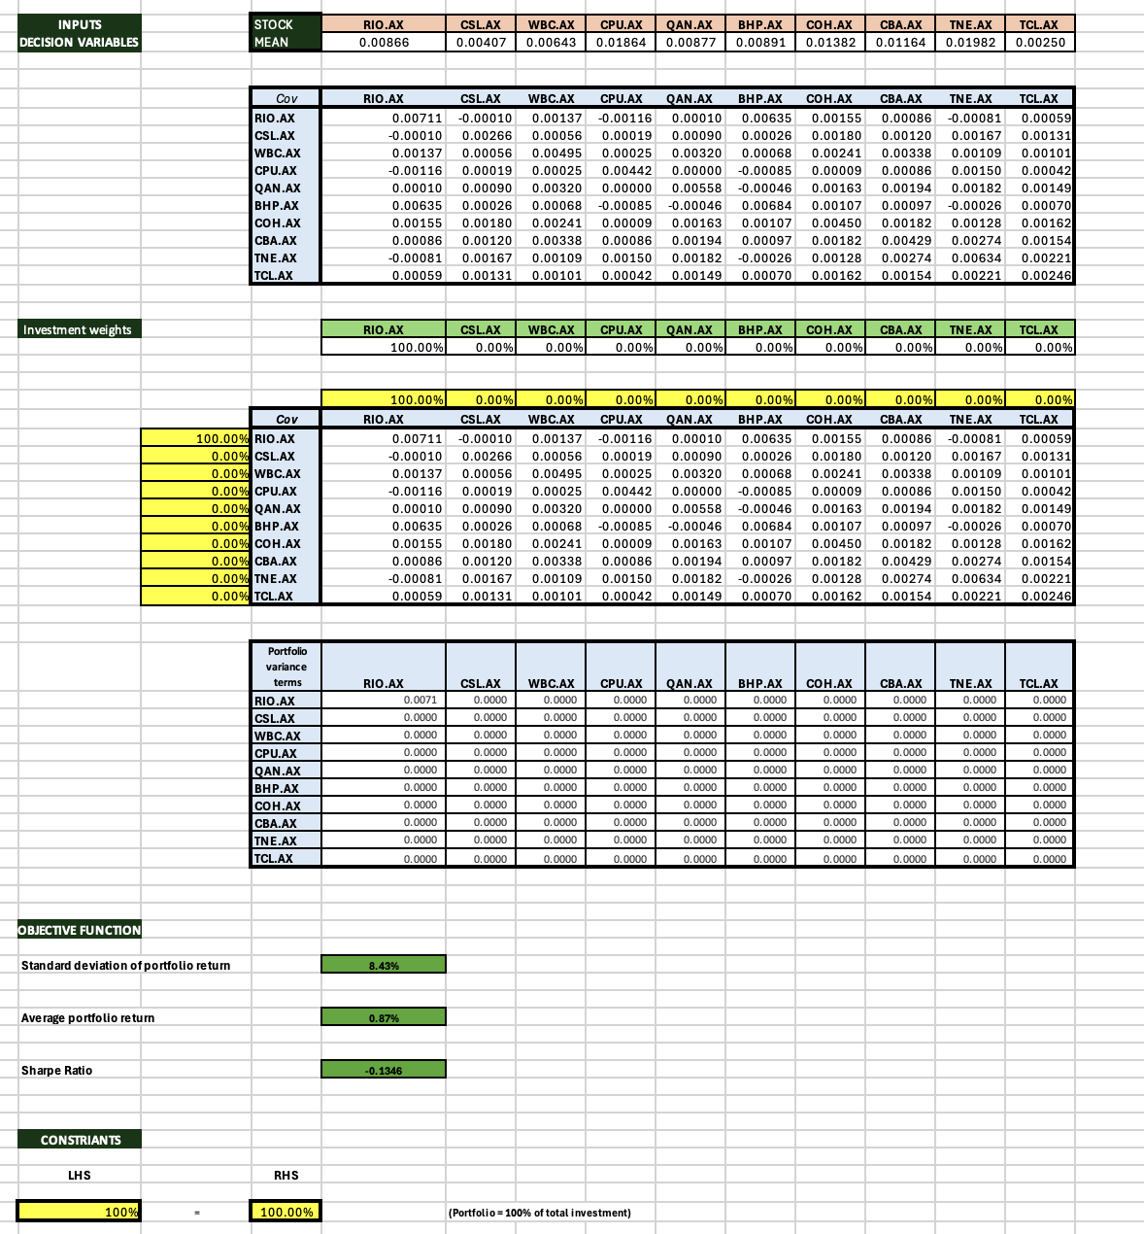

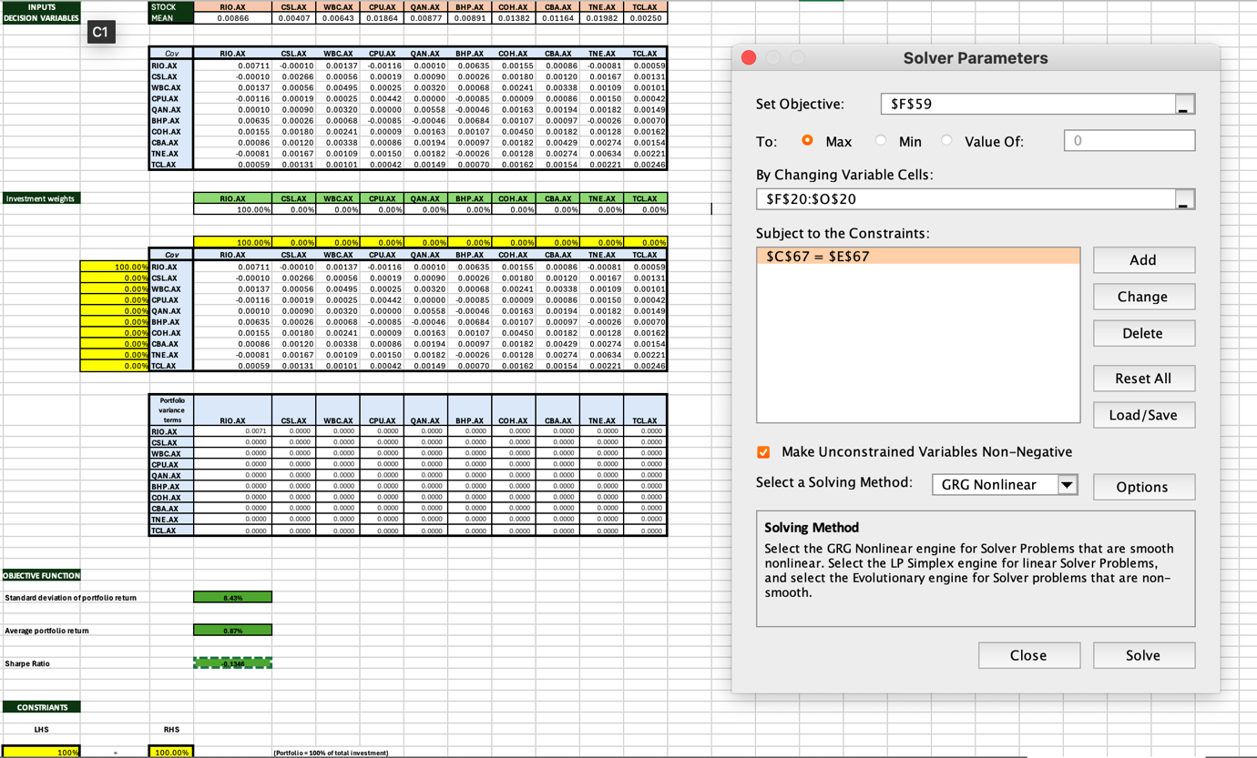

**Solver parameters for NLP model Sharpe ratio**

**Interpretation**

Sharpe ratio is a measure used to evaluate the risk-adjusted return of an investment or portfolio. In order to achieve the maximum of risk adjusted return considering a 2% risk free rate, one should invest 100% in RIO.AX

# **Section 3: OPTIMISATION RESULTS AND RECOMMENDED STRATEGY**

**Summary table(s) of results for all models.**

|  |  |  |
| --- | --- | --- |
| **Model** | **Objective Function** | **Result** |
| **Linear Programming** | **Average Portfolio Return** | **1.34%** |
| **Integer Linear programming** | **Average Portfolio Return** | **8.82%** |
| **Non - Linear Programming** | **Average Portfolio Return** | **1.43%** |
| **Non - Linear Programming** | **Standard deviation of portfolio** | **3.85%** |
| **Non - Linear Programming** | **Sharpe Ratio** | **-0.1346** |

**Preferred strategy**

Analysing the portfolio of 10 stocks invested in 5 different sectors running in different risk categories. NLP (b) model and ILP model gave the most optimal solutions and outcomes. Following the ILP model had a lot of constraints it suggested that which stocks we should invest in and will give us 8.82% of average returns which is reasonable. The NLP (b) Suggested to achieve minimum of 1.50% return how much risk will be associated in investing in different stocks, this mathematical model is very informative finding the risk niche and proportion of capital invested and constraints. 1.5% of average return with 3.85% of average risk associated certain stocks can vary which is pleasing to investors.

Lastly, this portfolio has a negative Sharpe ratio (NLP model) which is not very desirable. A negative Sharpe ratio signifies that the risk-free rate is greater than the historical return or the portfolio returns will be expected to be negative. However, if the risk-free rate is reduced to a lower percentage, then the solver procedure can be looped for better results, Hence if required it act as a informative indicator to change a few stocks in the portfolio for better risk-free returns in the future.